**Experiment No. 11**

**Aim: Make use of advance modules of Python like OpenCV, Matplotlib, NumPy**

**Code:**

**NumPy**

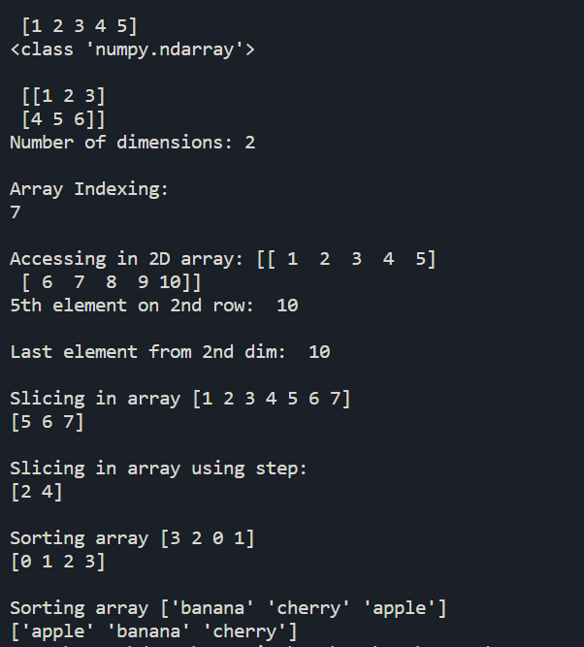import numpy as np

arr = np.array([1, 2, 3, 4, 5])

print("\n",arr)

print(type(arr))

arr2 = np.array([[1, 2, 3], [4, 5, 6]])

print("\n",arr2)

print("Number of dimensions:",arr2.ndim)

print("\nArray Indexing:")

print(arr[2] + arr[3])

arr = np.array([[1,2,3,4,5], [6,7,8,9,10]])

print("\nAccessing in 2D array:",arr)

print('5th element on 2nd row: ', arr[1, 4])

print('\nLast element from 2nd dim: ', arr[1, -1])

arr = np.array([1, 2, 3, 4, 5, 6, 7])

print("\nSlicing in array", arr)

print(arr[4:])

print("\nSlicing in array using step:")

print(arr[1:5:2])

arr = np.array([3, 2, 0, 1])

print('\nSorting array', arr)

print(np.sort(arr))

arr = np.array(['banana', 'cherry', 'apple'])

print('\nSorting array',arr)

print(np.sort(arr))

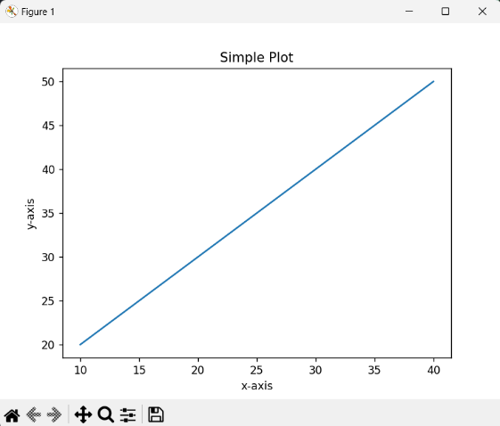

**Matplotlib:**

**Plotting a simple plot:**

import matplotlib.pyplot as plt

x = [10, 20, 30, 40]

y = [20, 30, 40, 50]

plt.plot(x, y)

plt.title("Simple Plot")

plt.ylabel("y-axis")

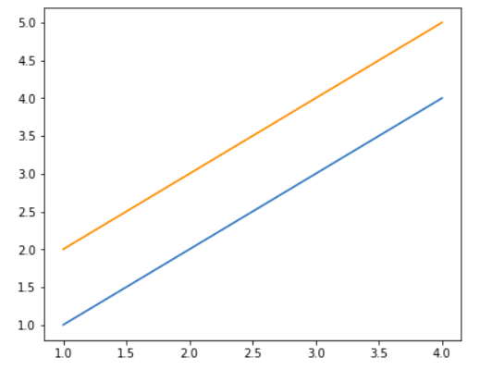plt.xlabel("x-axis")

plt.show()

**Plotting multiple lines:**

import matplotlib.pyplot as plt

from matplotlib.figure import Figure

fig = plt.figure(figsize = (5, 4))

ax = fig.add_axes([1, 1, 1, 1])

ax1 = ax.plot([1, 2, 3, 4], [1, 2, 3, 4])

ax2 = ax.plot([1, 2, 3, 4], [2, 3, 4, 5])

plt.show()

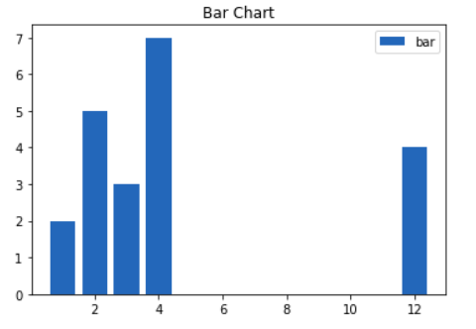**Plotting Bar Charts:**

import matplotlib.pyplot as plt

x = [3, 1, 3, 12, 2, 4, 4]

y = [3, 2, 1, 4, 5, 6, 7]

plt.bar(x, y)

plt.title("Bar Chart")

plt.legend(["bar"])

plt.show()

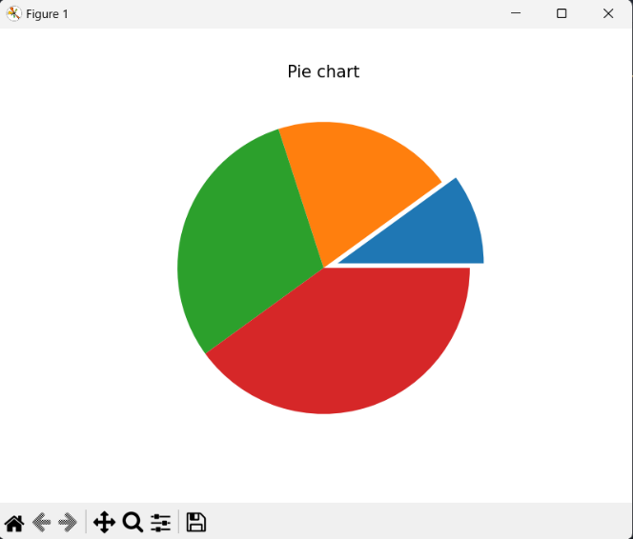**Plotting Pie Charts:**

import matplotlib.pyplot as plt

x = [1, 2, 3, 4]

e  =(0.1, 0, 0, 0)

plt.pie(x, explode = e)

plt.title("Pie chart")

plt.show()